**Needfinding Assignment**

Felix Andrei L. Pedro IV

Emily Grace V. Teodoro

BSIT – MI 182

UI/UX Design and Programming

**Activity**

Being in the shoes of an online buyer ((comparing prices and safety of buying from an online store)

With easy access to the internet it's easy for people to look for stores online and buy items online for the few reasons; (a) you can find variety of items, (b) the convenience of not having to attend to the physical store itself, (c) easy to compare prices and more affordable, and (d) there's no crowds to pressure the user when buying online. In here we will observe being in the place of an online buyer and the ups and downs and to help the user to become an efficient online buyer.

After our observations we prioritize the efficiency of comparing online website from one another based on their price difference and the safety of buying through one store and another.

**Observations**

We had interviewed a variety of people (student, working, and part timers) who has already had experience with shopping online, they stated their good and bad experience and the room for improvement to help new online shoppers. We only considered factors that could be avoidable such as the risk of paying for an item that can be bought cheaper from another online shop, terrible service and getting the wrong item from the badly rated shop or shops that have forged reviews. We interviewed them based on their experience of different shops, how they choose which shop to buy from based on the item their buying.

Here are our observations:



Figure 1 – A Shopee customer complaining about the product that they receive.

**Problem**: The items isn’t the same as the picture shown in the online shop.

**Need**: The buyer needs reassurance that the online store is giving proper description based on the item their selling. Instead of showing a stock picture they should show an accurate picture of the product their selling and not something their basing off from.

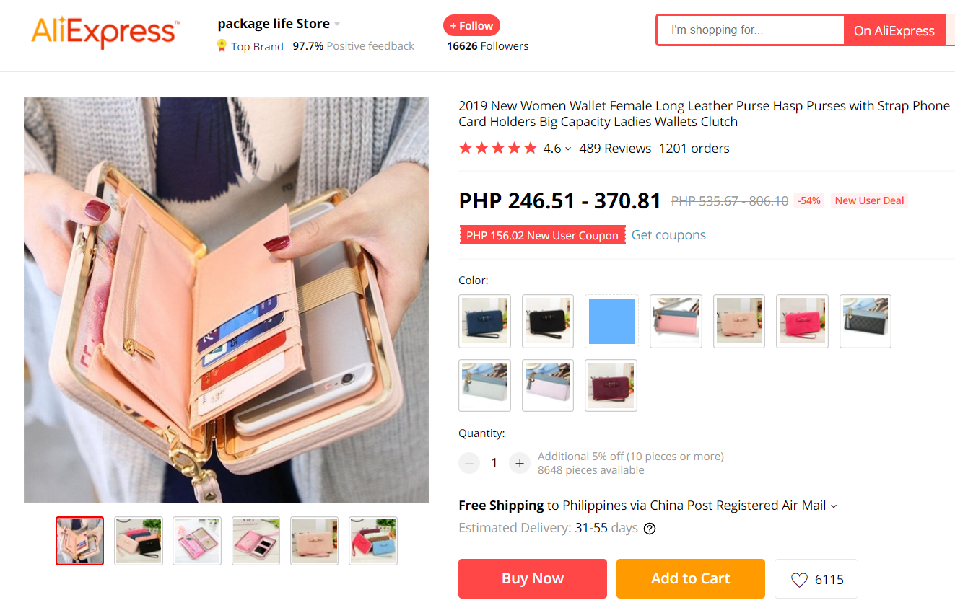 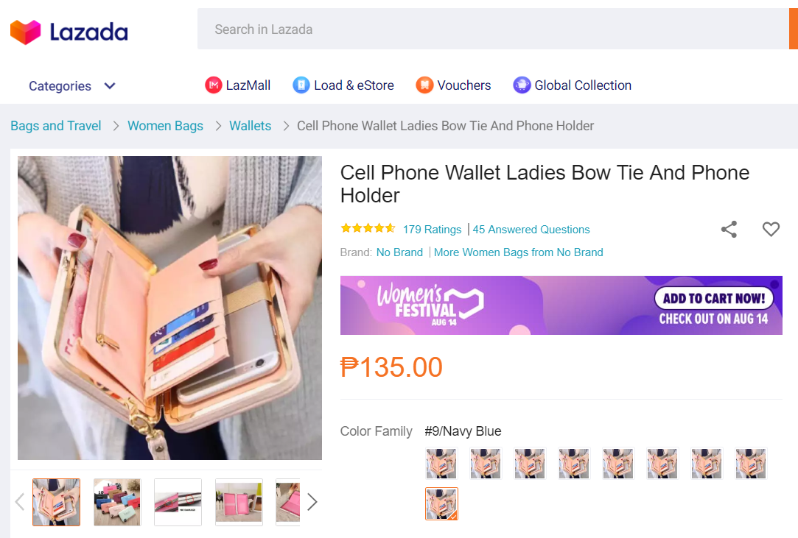

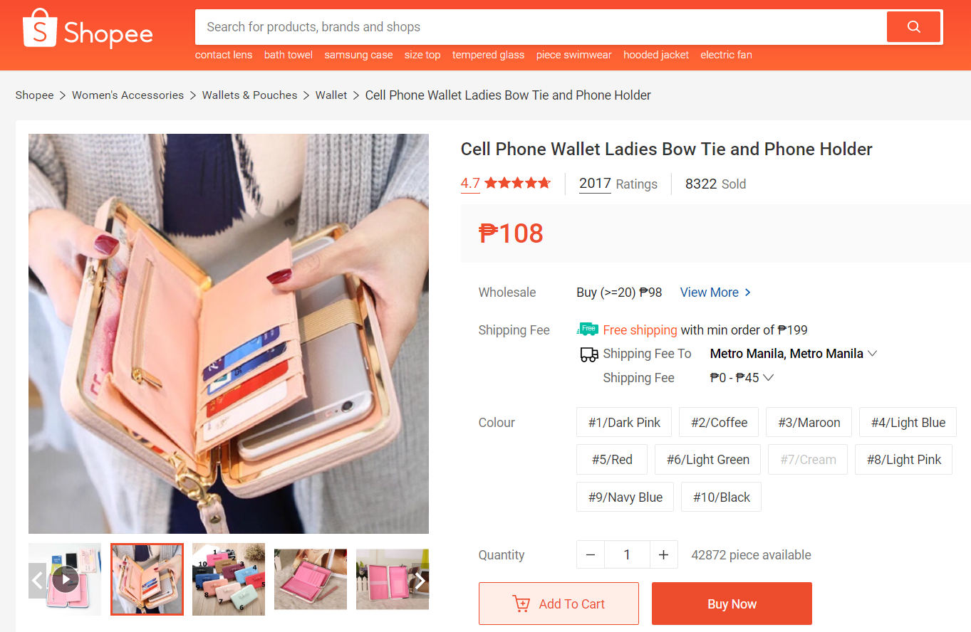

Figure 2 – The same wallet on Lazada, Ali Express, Shopee with its different prices.

**Problem**: The buyer would like an app that would help compare prices.

**Need**: There should be an application that can help the buyer compare prices from different sites, this includes the comparison of the store’s ratings, reviews, shipping fee and coupons if there is included

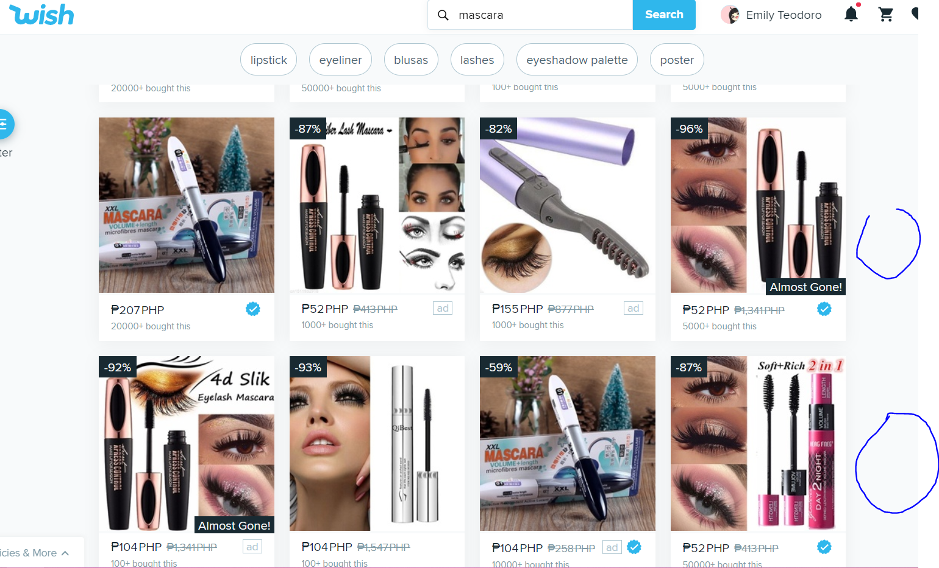

Figure 3 – The Wish website with the same product example but different name brand

**Problem**: The items in the online shops are the same.

**Need**: The online shops should show the proper product picture and not use stock pictures they show online. Wish is an example of a website that has different online sellers. There are variety of products that have different names or brands that share the same picture of a sample product.

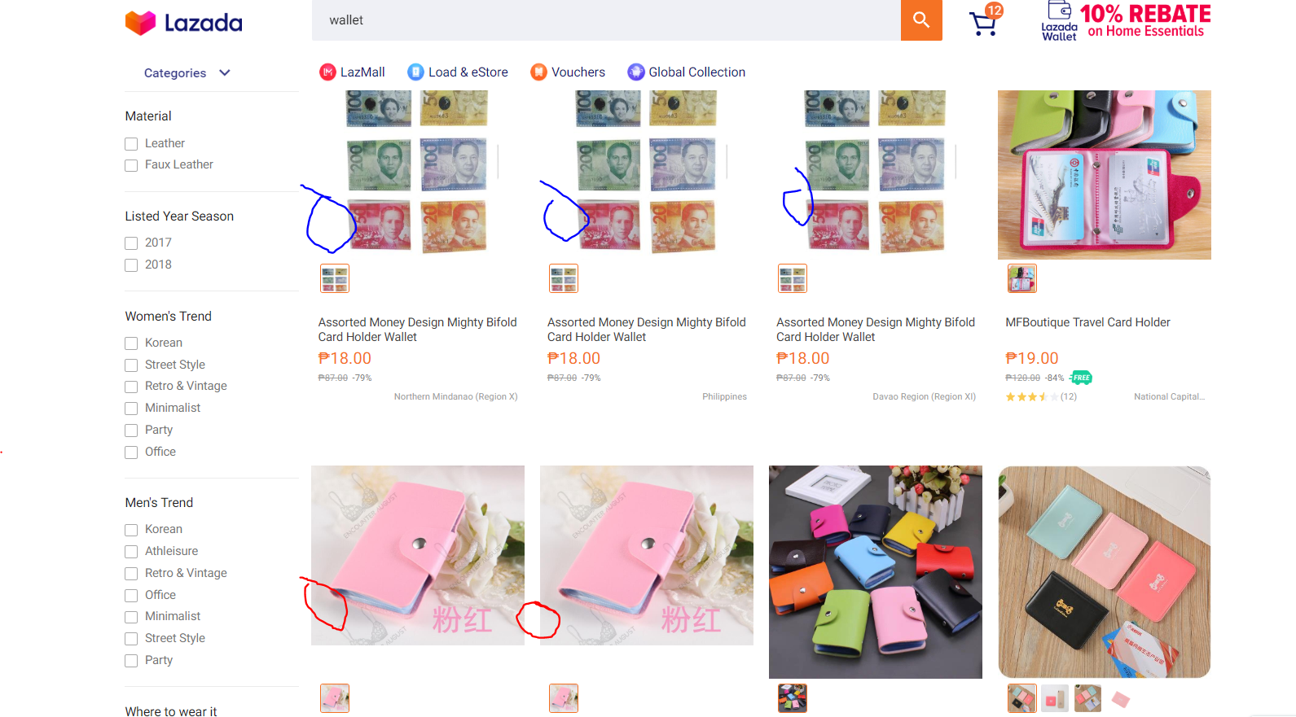

Figure 4 – The Lazada website with the same product example but from different stores.

**Problem**: The items in the online shops are the same.

**Need**:

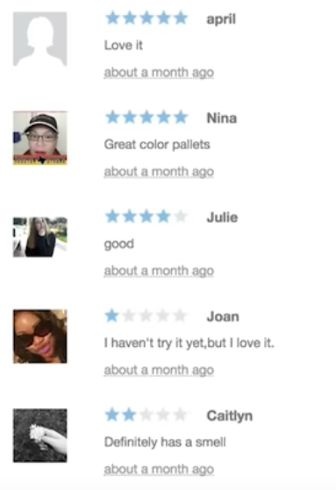

Figure 5 – This is from the website Wish where the reviews is about a blush palette. Notice that one person said that they love it but has 1 star.

**Problem**: The reviews on the online shop is forged.

**Need**: The online shop should have an authenticator that will show that it’s a legit buyer, and not have forged or copy paste reviews that is obviously made from bots.

**Interviews**

For our interview we asked 4 different people, a student who studied in APC, a graduate student from APC, our classmate who’s a tech journalist and pc enthusiast, and a previous worker of Amazon Utah.

**The Questions:**

**Question #1**: Do you have an online shopping application saved/downloaded/bookmarked on any of your devices?

(If yes, please list your favorite online shopping application) (If no, why not?)

**Question #2**: When shopping online do you compare prices based on the item you’re going to buy on different online stores?

**Question #3**: Are you aware of an application that can help you discover the different price alternatives with different stores?

**Question #4**: Do you base your choice with reviews or stars based on the item or shop?

**Question #5**: Have you ever bought something because it had "good reviews" or a cheaper price than other online stores? (Please state if you have good or bad experience)?

**Interviewee#1**: Katrina Maga, APC Student, CF-181



**Question #1**: Do you have an online shopping application saved/downloaded/bookmarked on any of your devices?

(If yes, please list your favorite online shopping application) (If no, why not?)

Yes, I have Shopee and Lazada.

**Question #2**: When shopping online do you compare prices based on the item you’re going to buy on different online stores?

Sometimes, but mostly the availability.

**Question #3**: Are you aware of an application that can help you discover the different price alternatives with different stores?

Nope.

**Question #4**: Do you base your choice with reviews or stars based on the item or shop?

Rarely, but if there are reviews, I usually read it first instead just the ratings. I need the detailed description.

**Question #5**: Have you ever bought something because it had "good reviews" or a cheaper price than other online stores? (Please state if you have good or bad experience)?

Yes, I have good experiences when I bought the item since my old item I bought from Lazada 5 years ago, until now it’s still working as new.

**Interviewee#2**: De'Shae Smith, Amazon Worker in Utah



**Question #1**: Do you have an online shopping application saved/downloaded/bookmarked on any of your devices?

(If yes, please list your favorite online shopping application) (If no, why not?)

Yes, I do! I have, Amazon, Best Buy, Walmart, And Target on my devices.

**Question #2**: When shopping online do you compare prices based on the item you’re going to buy on different online stores?

Of course, it’s good to find the best or the most matching price to find from different store to get a good deal.

**Question #3**: Are you aware of an application that can help you discover the different price alternatives with different stores?

No, I’m not but it would be helpful if there was one.

**Question #4**: Do you base your choice with reviews or stars based on the item or shop?

honestly look at both. Because they both provide good information if the item is reliable and see reviews if people are satisfied with the product/item.

**Question #5**: Have you ever bought something because it had "good reviews" or a cheaper price than other online stores? (Please state if you have good or bad experience)?

I usually go for a cheaper price first then a “good review”. And mostly my experience are good at the end of the day.

**Interviewee#3**: Ira James, Tech Journalist and PC Enthusiast



**Question #1**: Do you have an online shopping application saved/downloaded/bookmarked on any of your devices?

(If yes, please list your favorite online shopping application) (If no, why not?)

**Question #2**: When shopping online do you compare prices based on the item you’re going to buy on different online stores?

**Question #3**: Are you aware of an application that can help you discover the different price alternatives with different stores?

**Question #4**: Do you base your choice with reviews or stars based on the item or shop?

**Question #5**: Have you ever bought something because it had "good reviews" or a cheaper price than other online stores? (Please state if you have good or bad experience)?



**Interviewee#4**: Morrie Carmelo C. Felix, Tech Online Shopper

**Question #1**: Do you have an online shopping application saved/downloaded/bookmarked on any of your devices?

(If yes, please list your favorite online shopping application) (If no, why not?)

Yes. Lazada, Shopee, FoodPanda, Grab

**Question #2**: When shopping online do you compare prices based on the item you’re going to buy on different online stores?

Yes, but no I trust Lazada more than Shopee for products, if given the chance I would use Amazon, but it takes a month for it to be delivered. For food I compare from FoodPanda and GrabFood from time to time.

**Question #3**: Are you aware of an application that can help you discover the different price alternatives with different stores?

HONEY just cause of podcasts I listen to and they recommend it but I don’t know if it works for Lazada or Shopee.

**Question #4**: Do you base your choice with reviews or stars based on the item or shop?

No, sometimes it’s a forged review, but I mostly buy gadgets so if it breaks it could’ve been my fault.

**Question #5**: Have you ever bought something because it had "good reviews" or a cheaper price than other online stores? (Please state if you have good or bad experience)?

Yes, it was a bad experience, and from that exp I didn’t buy those anymore it was cheap and had good reviews, but it was to say the least terrible.

**Identified Needs**

Through our previous interviews and observations, we discovered the following needs that needs to be address and can be beneficial towards online shoppers.

* Interviewees suggests an application that will be easy to compare prices.
  + Since we questioned the interviewees if they knew any application that can help them check the price difference from other sites.
* Interviewees suggests an application that will be easy to compare shipping fee.
  + Since we questioned the interviewees if they knew any application that can help them check the price difference from other online shops, they also would like to include the different shipping fee costs.
* Interviewees suggests an application that will be easy to compare the online stores ratings and reviews
  + Since some of the interviewees likes the idea of going through an online store with good ratings and reviews, this could benefit the buyer to have this trust made between them and the seller.

Point of View

Need for better price comparison of online shops

* The buyer needs open multiple application and search one by one for the specific item they must order.
* If only the online shop has the appropriate liking to the buyer, such as good ratings and reviews, a good price, and an estimated shipping price then they save the item.
* The buyer then checks out other online shops and repeat the same steps.
* Only when they completed the online shops their trying to compare then they will decide where they will buy.

Need for coupons

Conclusion